**[12] Design DFA Which Accepts String**

* **A**
* **AC**
* **BAC**

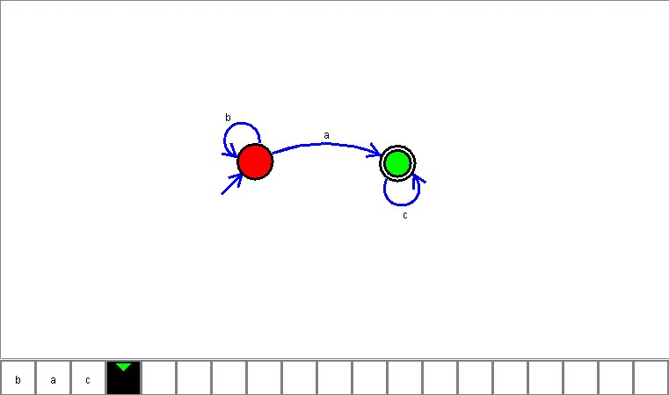

**Result**

The DFA is designed to compute the strings as input using Automaton Simulator